**W04 Group Project: CSS Zen Garden Introduction**

**Group Members**

Bryce Dickson

Matthew McCrary

Zak Shaik

**Theme Description**

Some find their “zen” in quiet gardens, and others find it behind a screen and gaming controller. We decided on a gaming themed CSS Zen Garden. It will be a dark theme with black and grey backgrounds, and blue accents to contrast. We’ll have a header image/block across the top, similar to Verde Moderna by Dave Shea, that incorporates a gaming controller silhouette. The silhouette would likely be a simple self-produced svg. The main content headings will be contained on lighter-colored semi-transparent blocks, with headings on blue overlay blocks.

Small Screen:

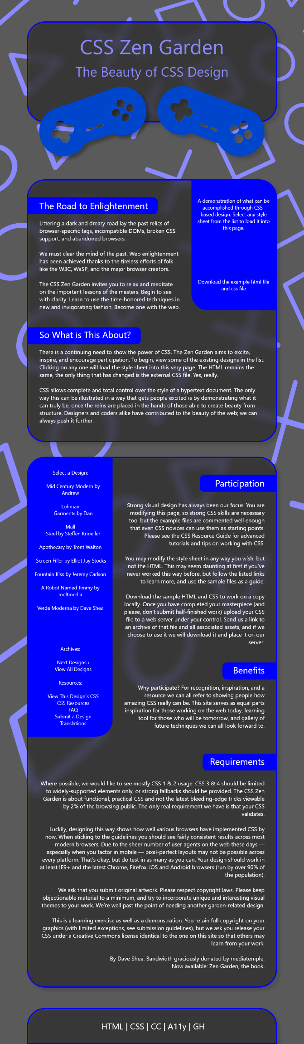

Large Screen:

